Ben Foster

Homework 4

TCSS 342

5/20/14

Question 1: Does your hash map offer O(1) performance?

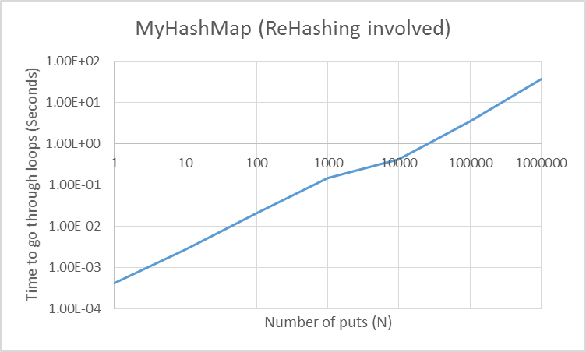

From the picture shown above, the line that is given on the log-log plot is almost linear.

This means that my hash map does in fact offer O(1) performace.

Question 2: Does rehashing significantly slow down your HashMap’s performace?

The graph above shows two lines. The orange line represents my Hashmaps performance when rehashing was involved while the blue line represents my Hashmaps performance when rehashing was not involved. They are very similar and at high N values, there is almost no effect.

Question 3: How does your HashMap’s performance compare to the JDK’s Hashmap?

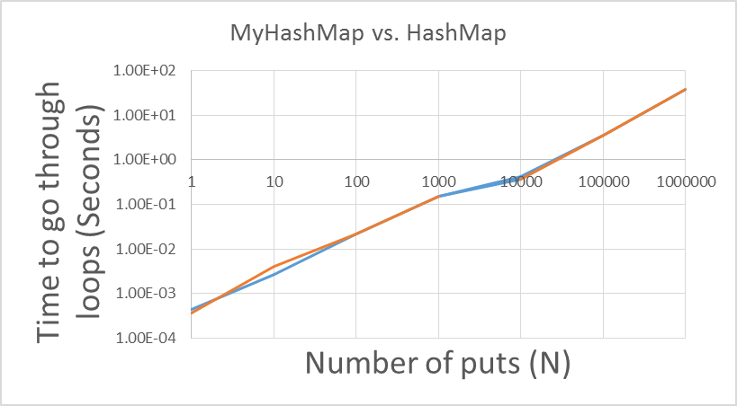

The graph above shows how long it took to complete MyHashMap and JDK’s Hashmap with different N’s. The blue line represents the performance time of my hasmap while the orange line represents the performance time of the JDK hasmap. Comparatively, they are almost identical.